**Real-Time Clock and Temperature Monitoring System**

**Aim:**

To design and simulate a real-time clock (RTC) and temperature monitoring system that issues a warning when the temperature crosses a predefined threshold.

**Problem Statement:**

Industries need continuous environmental monitoring for safety and operational efficiency. This system uses a real-time clock and temperature sensor to log temperature data and alert when it crosses a safe limit.

**Scope of the Solution:**

* Real-time temperature tracking with time reference.
* Automatic alert when threshold temperature is crossed.
* Useful in industries like food storage, pharmaceuticals, etc.
* Can be expanded with cloud connectivity and data logging.

**Required Components:**

* Wokwi Simulator
* Arduino IDE
* GitHub (to store and document code)

(Optional) Cloud:

* If cloud extension is needed: ThinkSpeak/MQTT dashboard

**Flowchart of the Code:**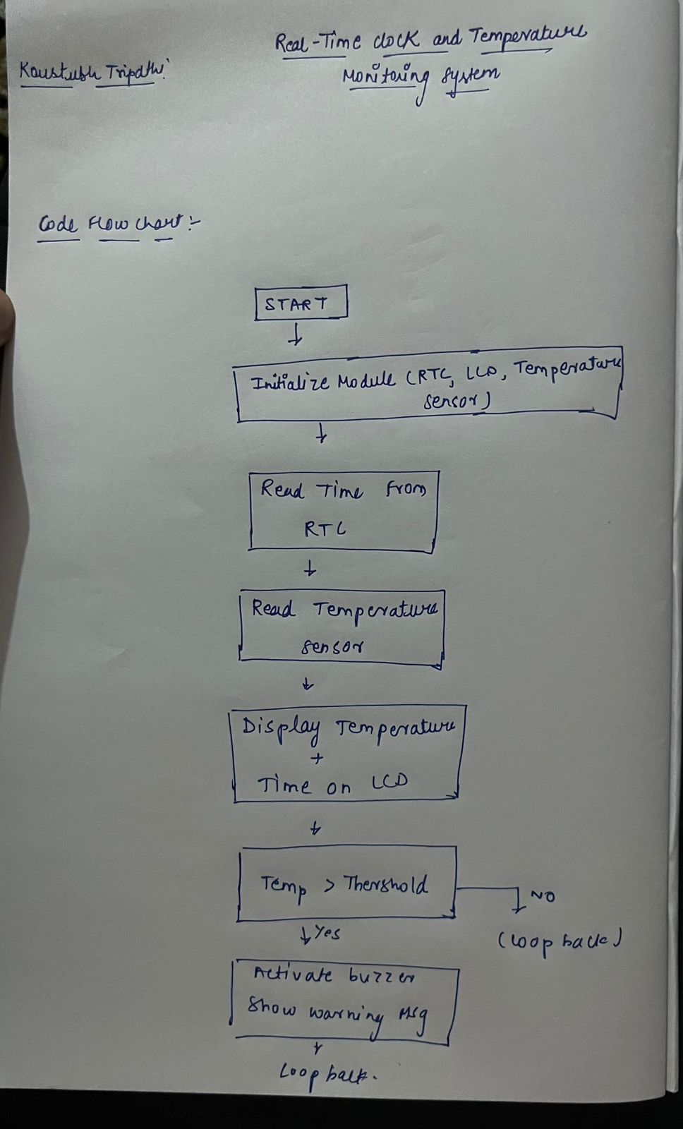

**Simulated Circuit (Wokwi):**

